How to add Rhombus to System Surveyor

This document will walk your through how to add Rhombus hardware to your System Surveyor profile to then add them to maps.

Step 1: Create a System Surveyor Account
- Click this link and enter in the fields appropriately

Step 2: Go to this link and download the below files
- 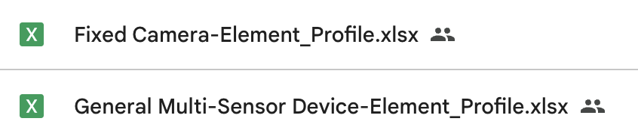

Step 3: Login to your account and navigate to "Profile"
- Click the Settings in the upper left of the screen and then click on "Profile"
- 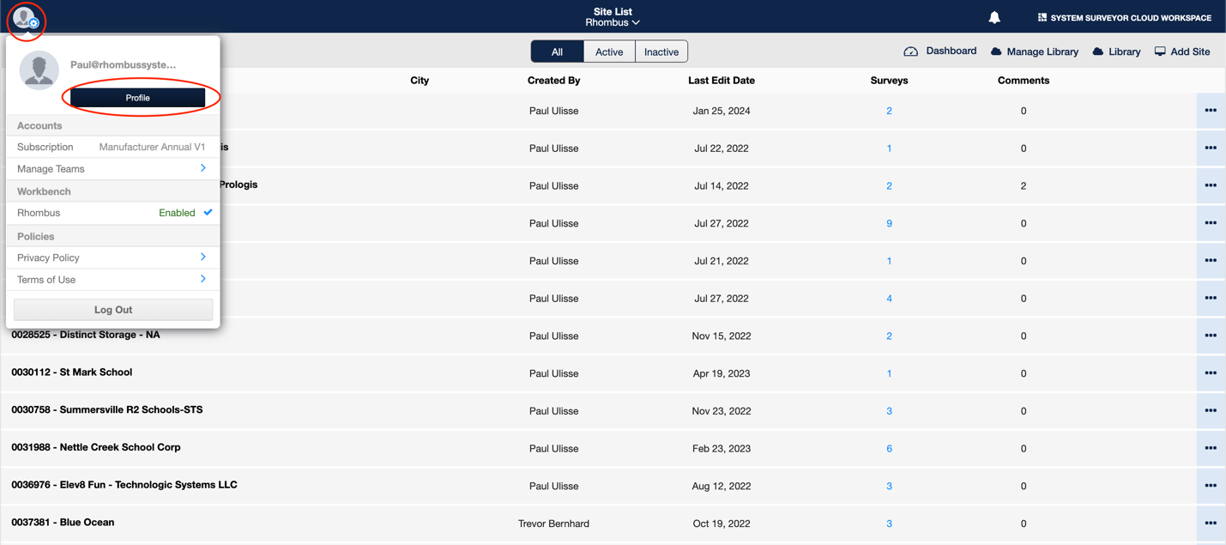
Step 4: Click on "Element Profile"
- 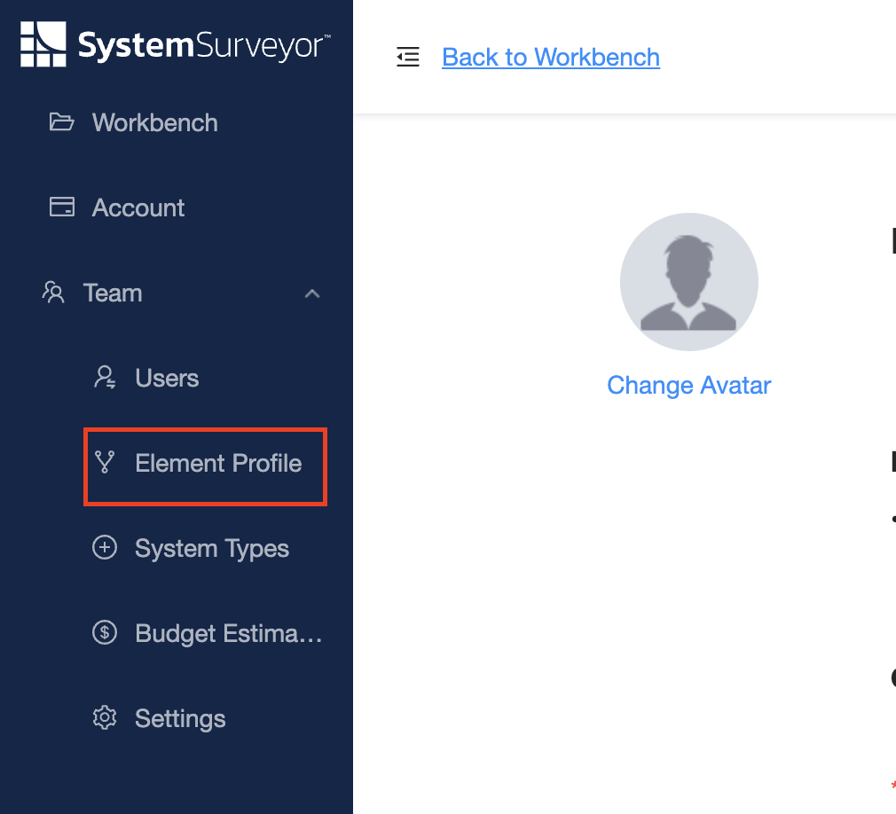

Step 5: Click on the "Video Surveillance" drop down and then "Fixed Camera"
- 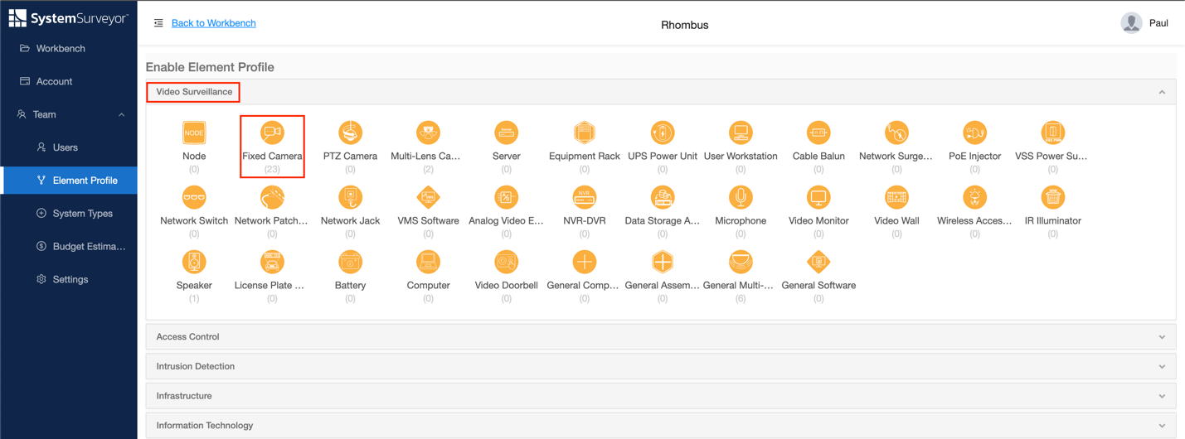

Step 6: Click on "IMPORT" in the upper right
- 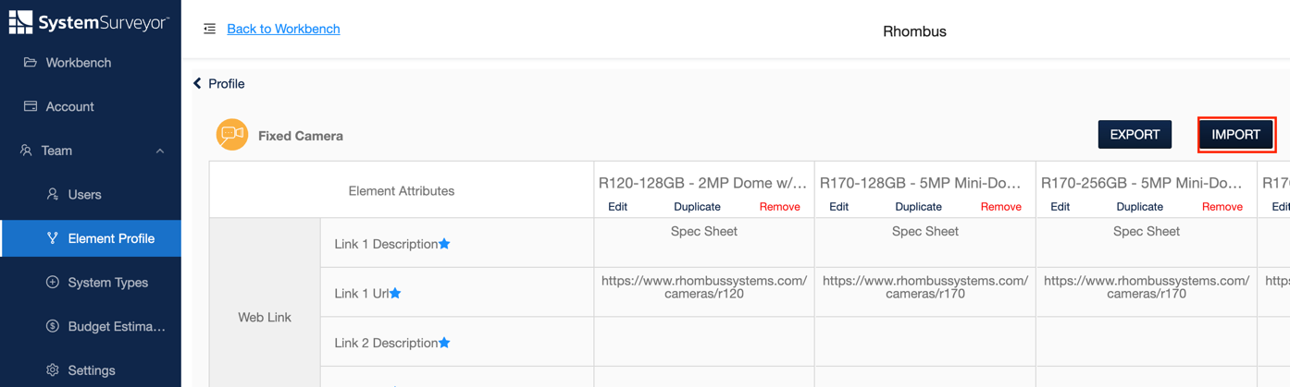

Step 7: Select "Fixed Camera-Element_Profile.xlsx" and click Open
- 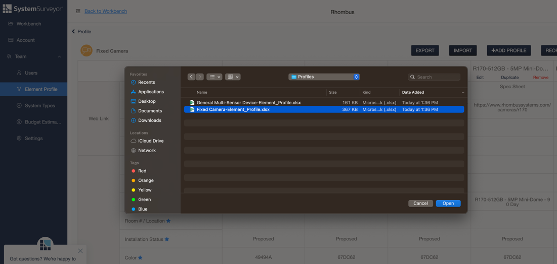
- Once the file has been process click "IMPORT"
- 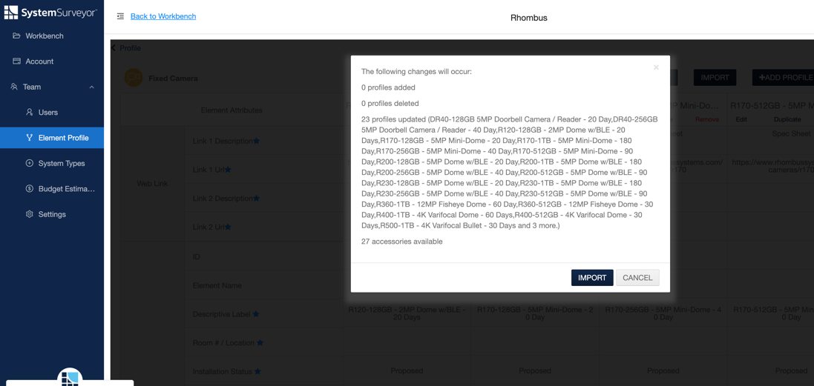

Step 8: Next we will add sensors, go back to Element Profile and then under Video Surveillance and click on "General Multi-Sensor"
- 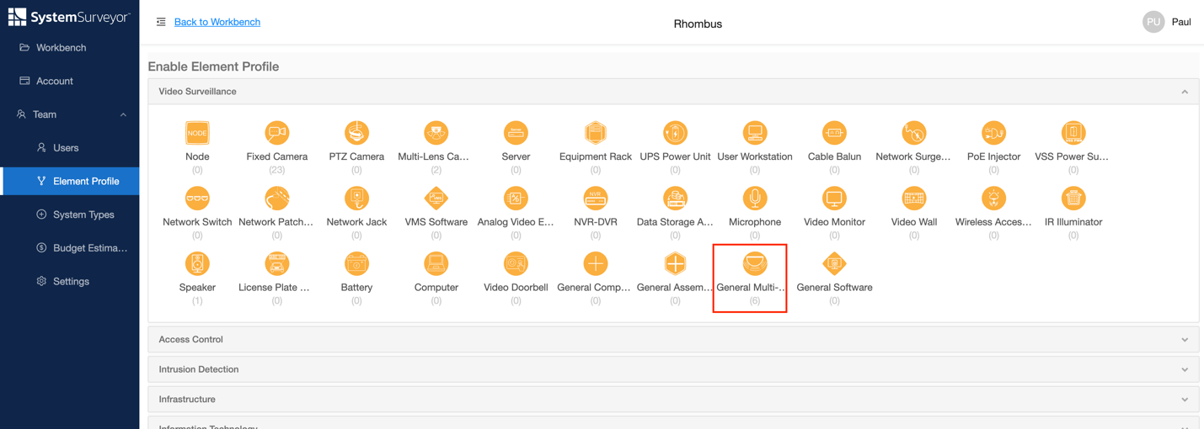

Step 9: Click on "IMPORT" button in the upper right
- 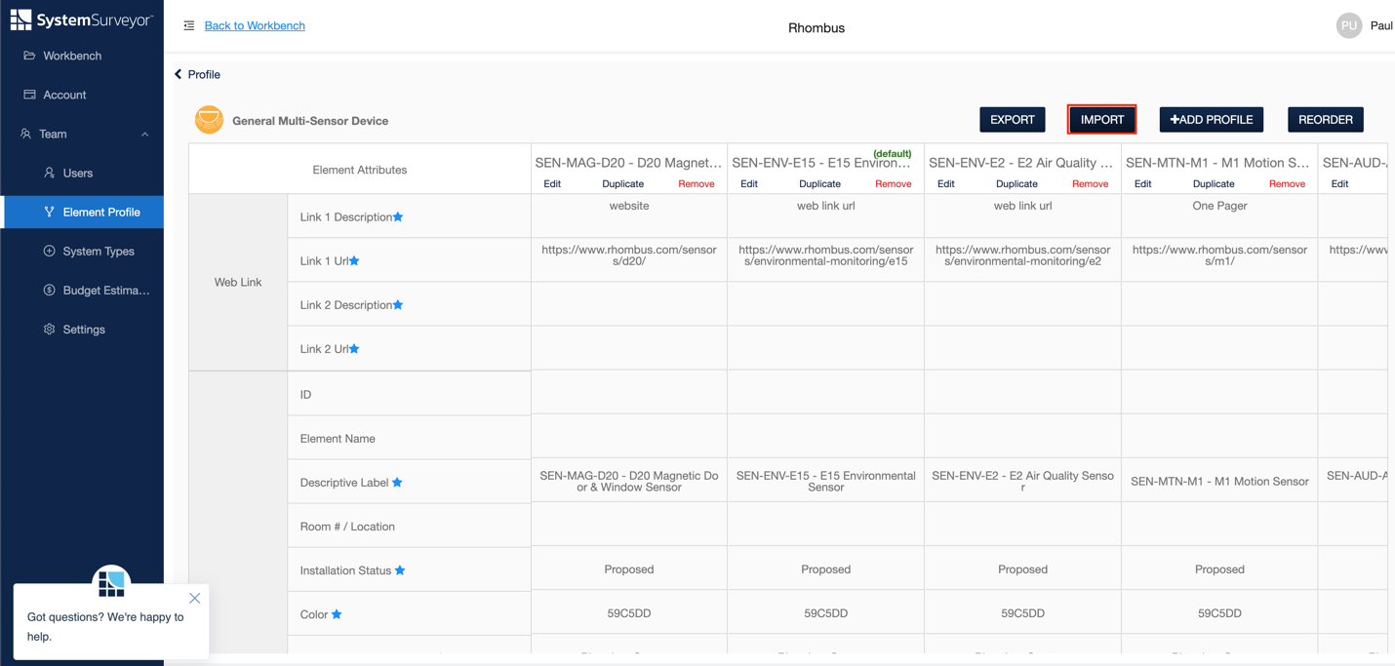

Step 10: Select the "General Multi-Sensor Device-Element_Profile.xlsx" file and click "Open"
- 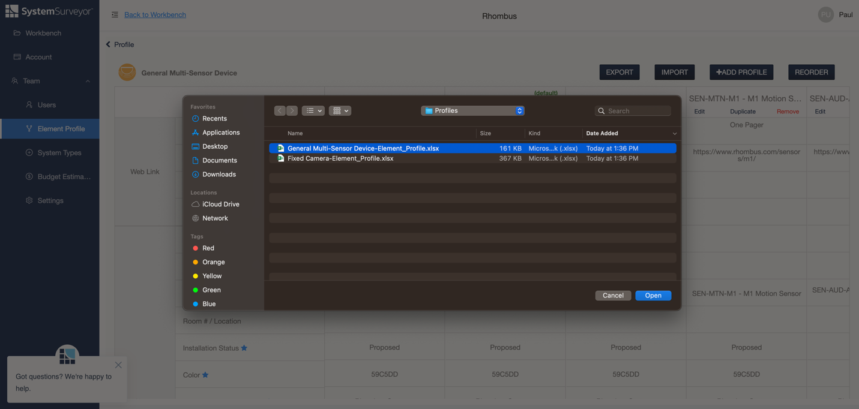
- Finally Click on "IMPORT" to finish this step
- 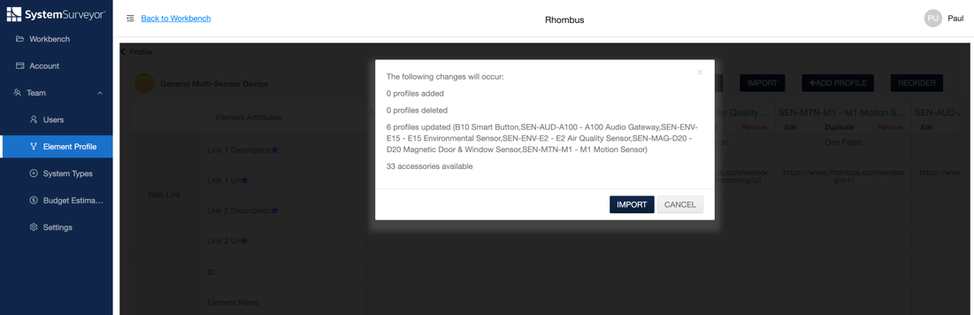

Step 11: Now you will be able to click and drop Cameras and Sensors onto maps!

